A
A

Identification of Genetic Variants Involved in Breast Cancer Using the RNA Seq Technique

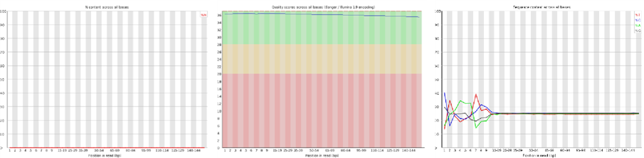
A B C
A

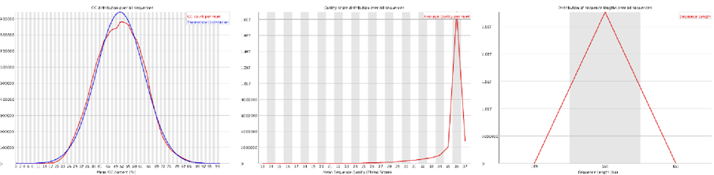
D E F
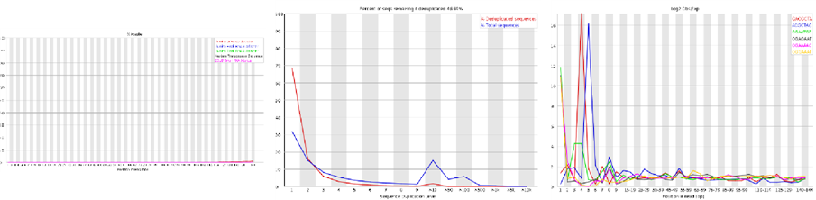

G H I
Figure 1SA. images about quality control ofshC-2 . A) Adapter content, b) Duplication levels, c) kmer profiles, d) Per base N-content, E) Per base sequence content, F) Per sequence –content, G)Per sequence gc-content, H) Per sequence quality, I) Sequence length distribution

A B C
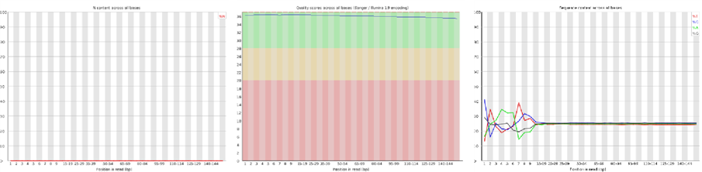

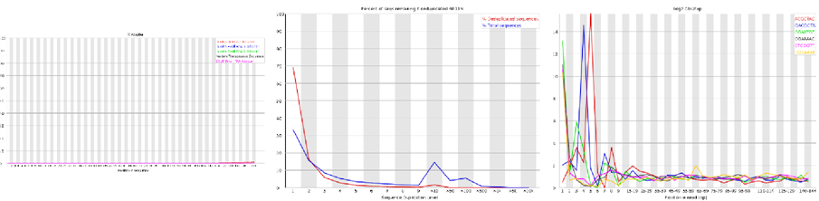

D E F
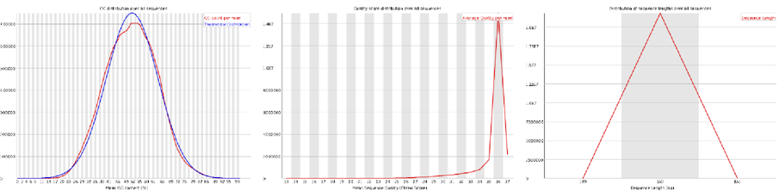
G H I

Figure 1SB. images about quality control ofshC-3 . A) Adapter content, b) Duplication levels, c) kmer profiles, d) Per base N-content, E) Per base sequence content, F) Per sequence –content, G)Per sequence gc-content, H) Per sequence quality, I) Sequence length distribution

A B C
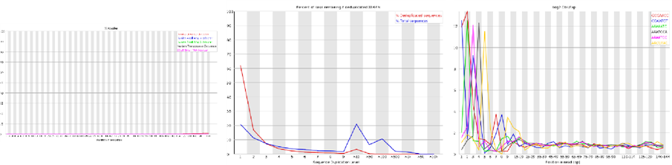
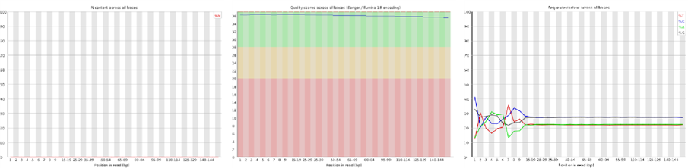

D E F
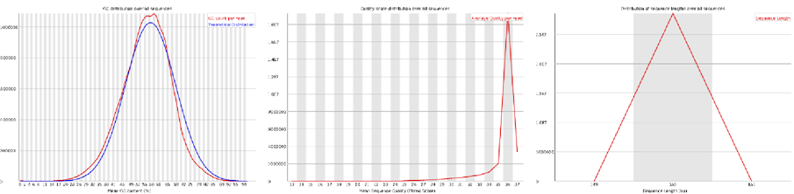
G H I

Figure 1SC. images about quality control ofshC-4 . A) Adapter content, b) Duplication levels, c) kmer profiles, d) Per base N-content, E) Per base sequence content, F) Per sequence –content, G)Per sequence gc-content, H) Per sequence quality, I) Sequence length distribution

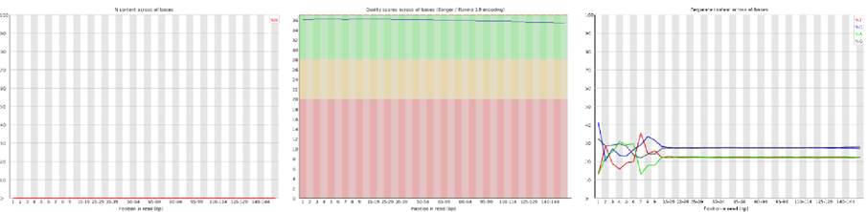

A B C

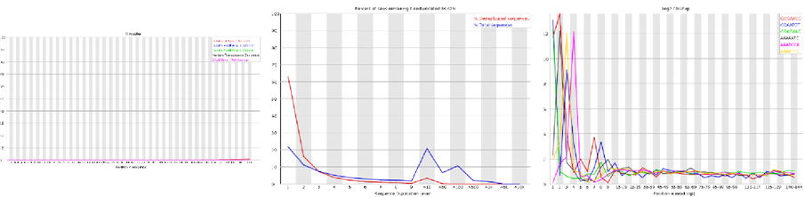

D E F
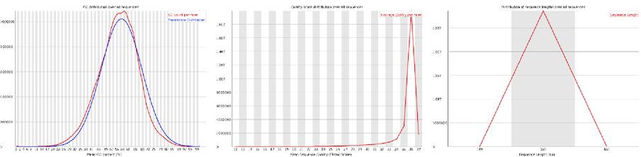

G H I

Figure 1SD. images about quality control ofshMETTL18-^{1.1}. A) Adapter content, b) Duplication levels, c) kmer profiles, d) Per base N-content, E) Per base sequence content, F) Per sequence –content, G)Per sequence gc-content, H) Per sequence quality, I) Sequence length distribution

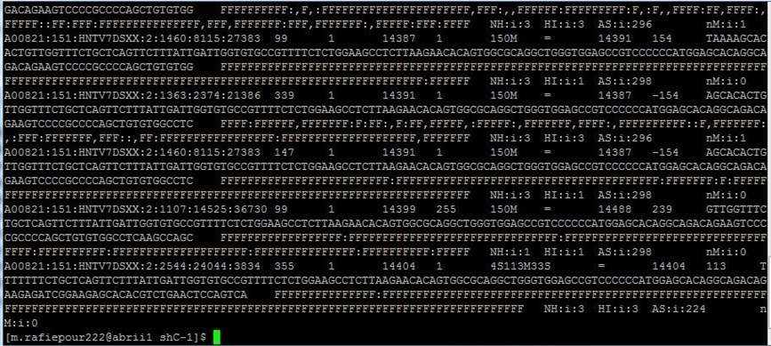
Figure 2S A. Images about SAM file of MarkDuplicates
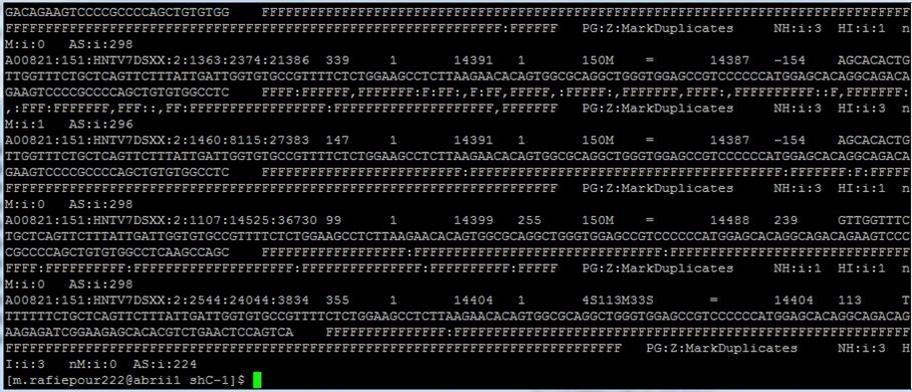
Figure 2SB . Images about SAM file ofSplitNCigarReads

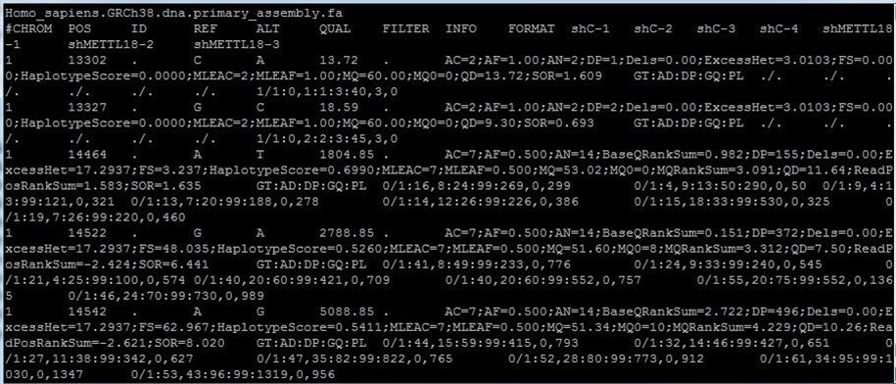
Figure 2SC. Images about SAM file ofVariant Calling

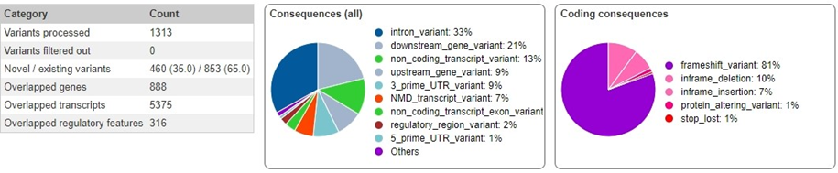
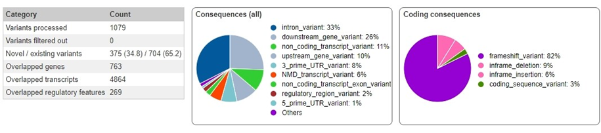

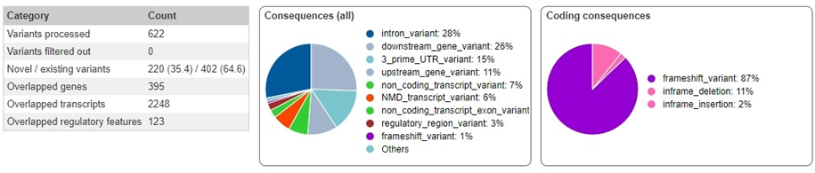

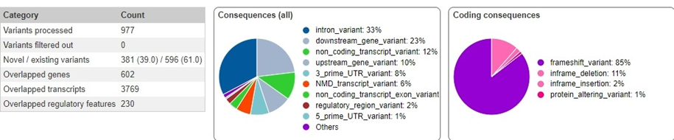

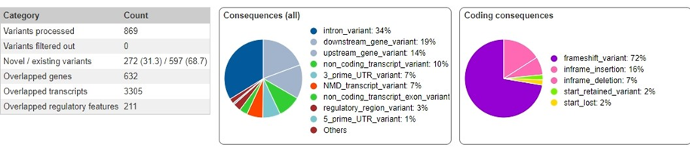

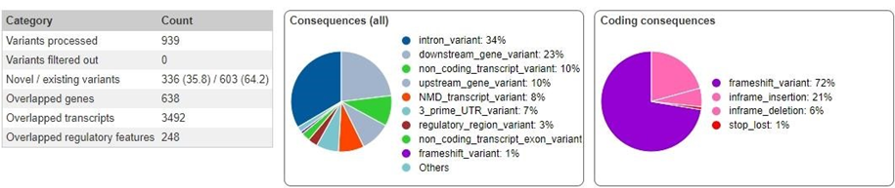

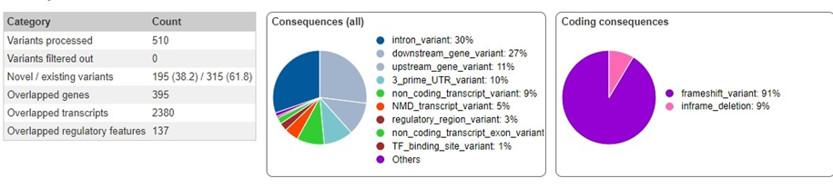

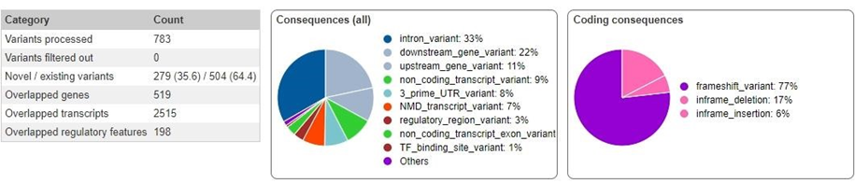

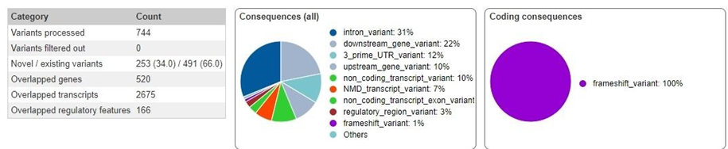

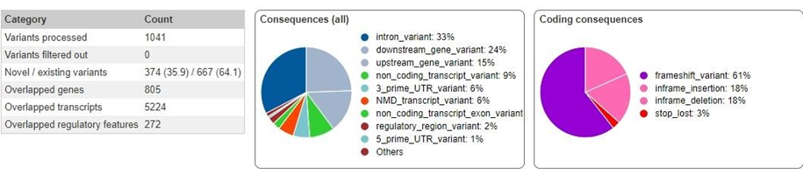

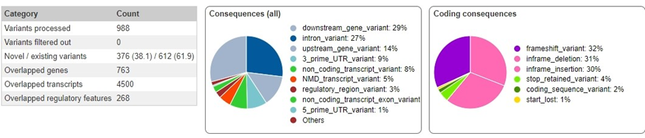

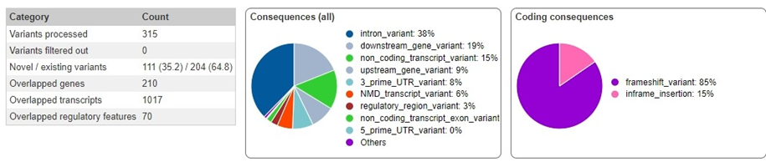

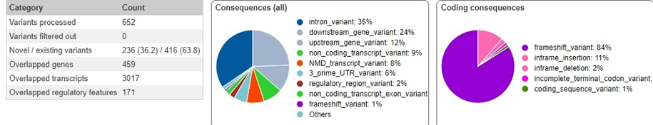

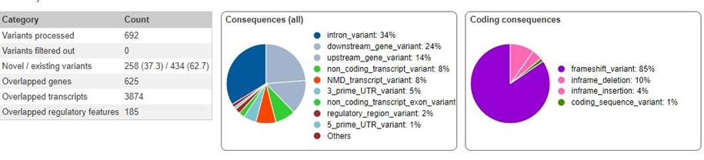

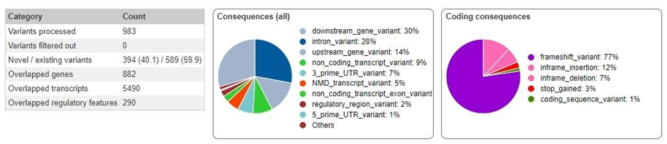

Figure 3s. results about indel of chromosome (2-22)

